Chapter 1 Question 20 Michael Streyle

##   
## Call:  
## lm(formula = Minutes ~ Copier_serviced)  
##   
## Coefficients:  
## (Intercept) Copier_serviced   
## -0.5802 15.0352

## Analysis of Variance Table  
##   
## Response: Minutes  
## Df Sum Sq Mean Sq F value Pr(>F)   
## Copier_serviced 1 76960 76960 968.66 < 2.2e-16 ***  
## Residuals 43 3416 79   
## ---  
## Signif. codes: 0 '***' 0.001 '**' 0.01 '*' 0.05 '.' 0.1 ' ' 1

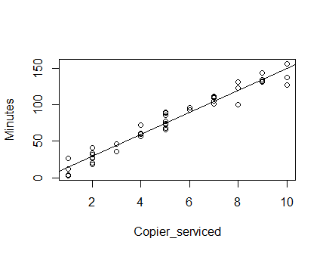

## (Intercept)   
## 74.59608

The intercept is -0.58 minutes and the slope is 15.0352 minutes unit per copier serviced.

Answers Written Out #20

1. The estimated regression function is Ŷ = -0.5802 + 15.0352(X).
2. The estimated regression function appears to fit the data very well.
3. The β0 value is -0.5802 which means for 0 copier machines, it takes -0.5802 minutes of service. This doesn’t provide any relevant information here, because if there are no machines to be serviced, it would take zero minutes. Also, Y is in minutes and negative minutes are not very plausible.
4. When X = 5, the point estimate of the mean service time is 74.59608 minutes.